Handout no. 8

|  |  |
| --- | --- |
| **Name** | **M.Umar Saleem, M Usama, Abdul Jabbar** |
| **Reg. No** | **2019-EE-356,366,376** |
| **Marks/Grade** |  |

**EXPERIMENT # 8**

**Parameter setting of Earth Overcurrent Relay for transmission line protection.**

**Objective:**

At the end of this lab session students will be able to

* Use De Lorenzo power system Protection kits.
* Implement Earth Overcurrent Relayby using De Lorenzo power system Protection kits.
* Relay behaviour in three phase systems for Overcurrent conditions.
* Determination of resetting ratio

**Introduction:**

A relay is usually an electromechanical device that is actuated by an electrical current. The current flowing in one circuit causes the opening or closing of another circuit. Relays are like remote control switches and are used in many applications because of their relative simplicity, long life, and proven high reliability. Relays are used in a wide variety of applications throughout industry, such as in telephone exchanges, digital computers and automation systems. Highly sophisticated relays are utilized to protect electric power systems against trouble and power blackouts as well as to regulate and control the generation and distribution of power. In the home, relays are used in refrigerators, washing machines and dishwashers, and heating and air-conditioning controls.

Although relays are generally associated with electrical circuitry, there are many other types, such as pneumatic and hydraulic. Input may be electrical and output directly mechanical. All relays contain a sensing unit, the electric coil, which is powered by AC or DC current. When the applied current or voltage exceeds a threshold value, the coil activates the armature, which operates either to close the open contacts or to open the closed contacts. When a power is supplied to the coil, it generates a magnetic force that actuates the switch mechanism

**Apparatus:**

* 1DL 1017R Resistive Load
* 1DL 2108T15 Earth Fault Warning Relay
* 1 DL 1013T1 Three Phase power Supply Unit
* 1 DL 2108TAL-SW Three Phase power Supply Unit
* 1 DL 2108T17 LC load
* 1 DL Buz Acoustic continuity tester

**Overcurrent Relay:**

In an over current relay, there would be essentially a current coil. When normal current flows through this coil, the magnetic effect generated by the coil is not sufficient to move the moving element of the relay, as in this condition the restraining force is greater than deflecting force. But when the current through the coil increased, the magnetic effect increases, and after certain level of current, the deflecting force generated by the magnetic effect of the coil, crosses the restraining force, as a result, the moving element starts moving to change the contact position in the relay. Although there are different types of over current relays but basic working principle of over current relay is more or less same for all.

**Earth Fault Relay:**

Earth fault is the unintended fault between the live conductor and the earth. It also occurs, because of the insulation breakdown. When the fault occurs, the short-circuit currents flow through the system, and this current is returned through the earth or any electrical equipment. This fault current damaged the equipment of the power system and also interrupted the continuity of the supply.

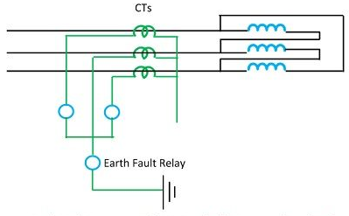

Figure 1: Earth fault Relay

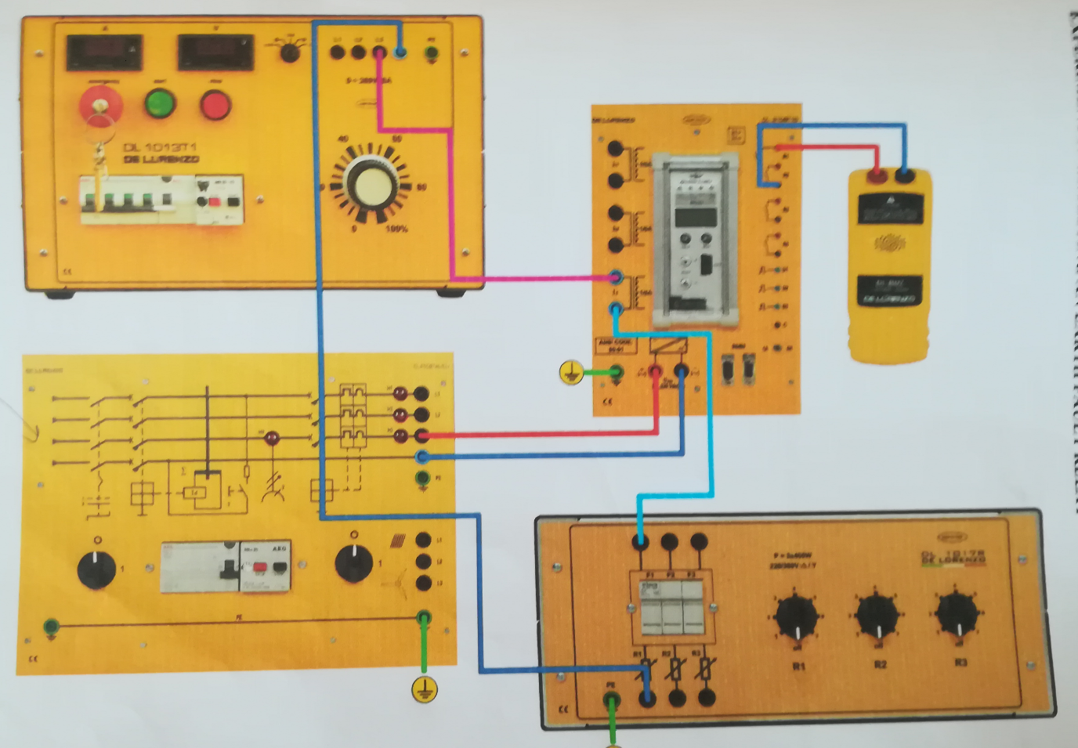

Figure 2: Experimental Setup of Earth Overcurrent Relay

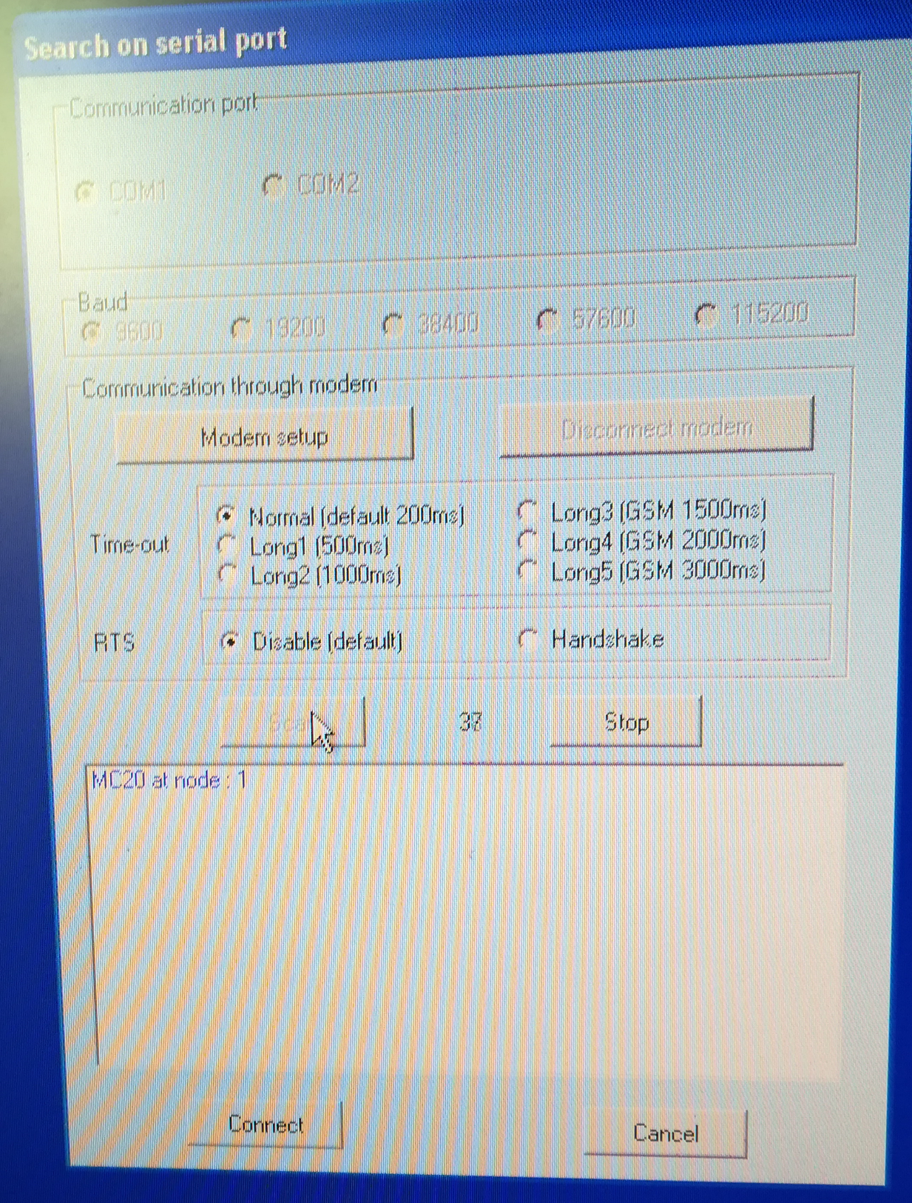

Figure 3: Create communication link of Relay

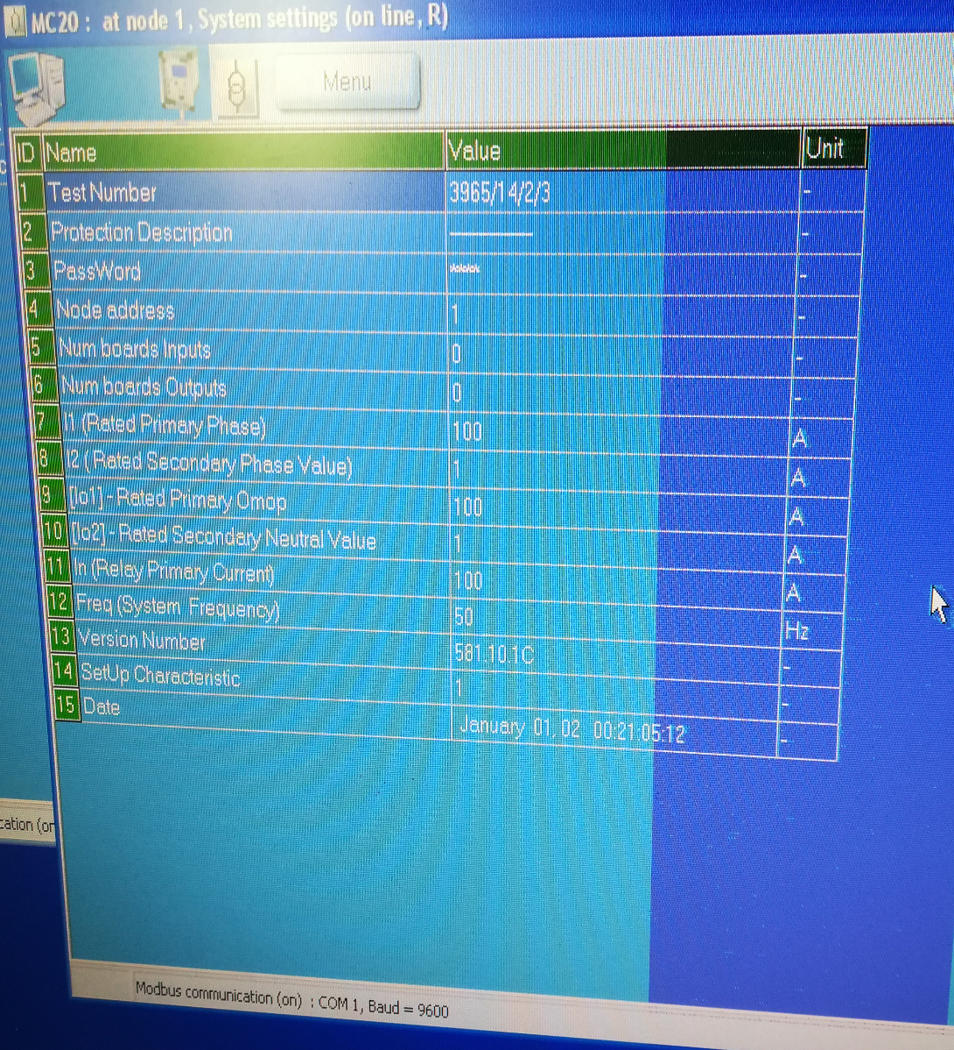

Figure 4: Setting of Fault current Value under fault condition

**Procedure:**

* Connect circuit as shown in Fig 2
* Create communication link of Relay
* Set the fault current value.
* Set three phase power supply voltage 380v and relay is not in operation
* Starting from 0V slowly increase the value of three phase supply voltage until the overcurrent relay operates.
* Then slowly decrease the voltage until the relay release and Reset the Relay.
* Apply same procedure for different timer conditions

|  |  |  |  |
| --- | --- | --- | --- |
| **Set value of Io** | **Trip value of I01=** | **Measured Value** | **Error %** |
| **150** | **30** | **30.5** | **0.98** |
| **200** | **40** | **41.6** | **0.96** |
| **300** | **60** | **61.5** | **0.975** |
| **350** | **70** | **70.5** | **0.99** |

**Observation:**

* Use De Lorenzo power system Protection kits.
* Implement Earth Overcurrent Relayby using De Lorenzo power system Protection kits.

Relay behaviour in three phase systems for Overcurrent conditions

**Observations:**

In this lab we learnt about the use of De Lorenzo power system Protection kits for determining the behaviour of relay in three phase systems for Overcurrent conditions for this we setting the Parameters of Earth Overcurrent Relay for transmission line protection and then create communication link of Relay then first of all we reset the all values and then turn noob at zero point then gradually rotate the noob so that increase the voltage and check the value at which the overcurrent relay operates we visualize with the help of LED and note the value at which relay operate and then we open the software on the desktop and this same value of relay operating we will see on software and compare with our practical value after this we decrease the value of voltage by rotating noob in reverse direction and also reset the value of relay operating So we repeat this same process for different values in order to get the different values of relay operating. At last we fill the values on manual and compare the actual and calculated values and then find error